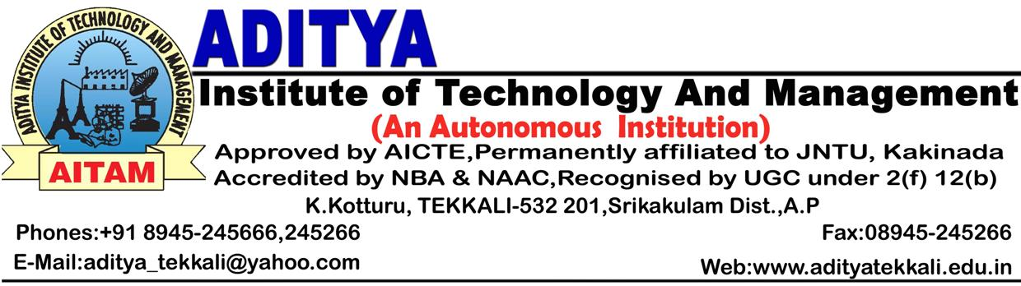 Date : 04.05.2015

CONGRATULATIONS

On behalf of the Management, I congratulate Dr.G.Nageswara Rao, Professor of IT Dept. for the award of Doctor of Philosophy Degree (Ph.D) from Andhra University.

I also congratulate Dr.G.Nageswara Rao for nomination as a member of the Section Managing Committee of ISTE, Andhra Pradesh Section for a period of 3 years by Indian Society for Technical Education.

I wish him all the success in his future endeavors.


DIRECTOR

cc: Principal / All HODs / P.File.

